Nesselue Hat -- A version of the Melt the ICE hat.
©Hazel Spencer 2025
Using the 12" Square Quilt Weaver loom, warp three layers as in the pictures. You'll need 9 wraps to measure the weft. If you do not want to drag 12 or so yards of weft though, you can do this in shorter pieces but you will have to join them in some way. Your choice. Some yarns won't stand the friction of the long drags so it might be worth working shorter hiding your joins. The yarn I used in this one was a slightly bulky wool. I recommend using a worsted weight as this yarn was a bit too stiff but what I had in stock at the time. Handspun would be good, too.
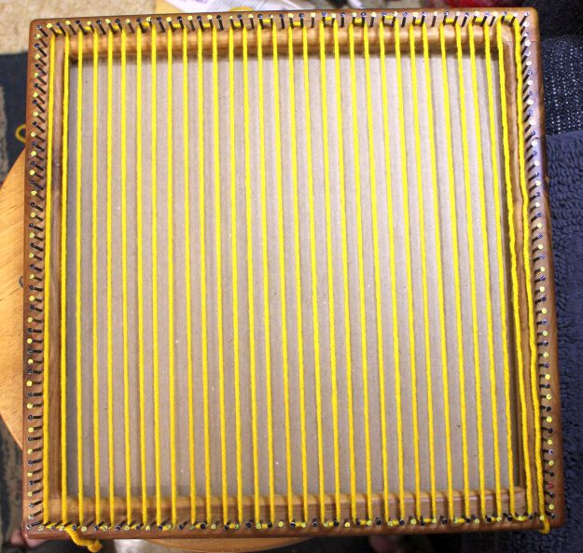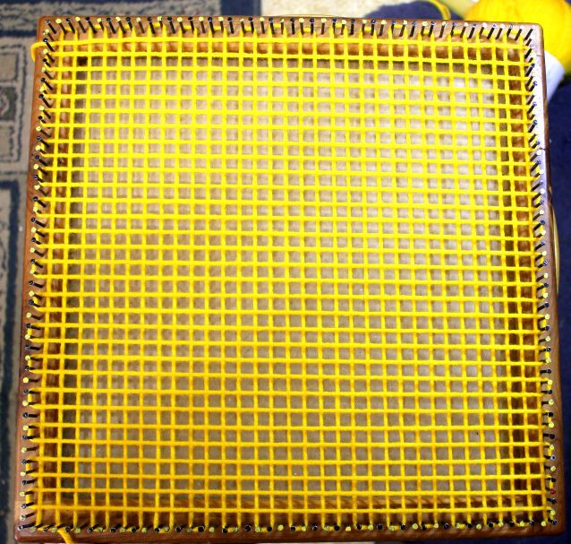
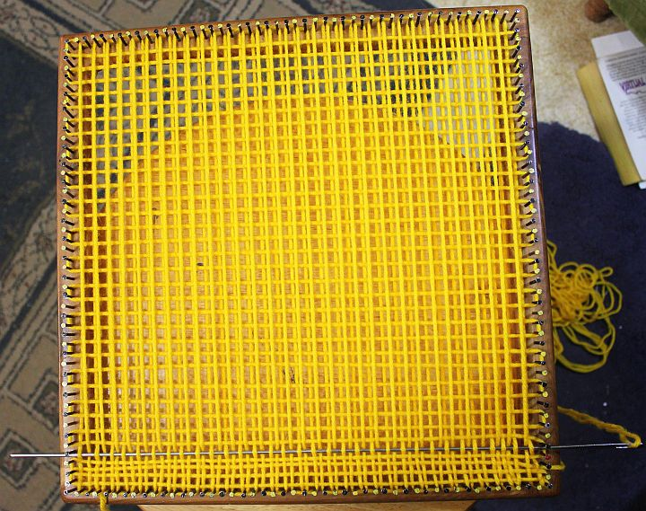

Start weaving as always with the first row right up next to the nails, over-under across.
Row 2, weave 28, u1, slide to last warp, u1*
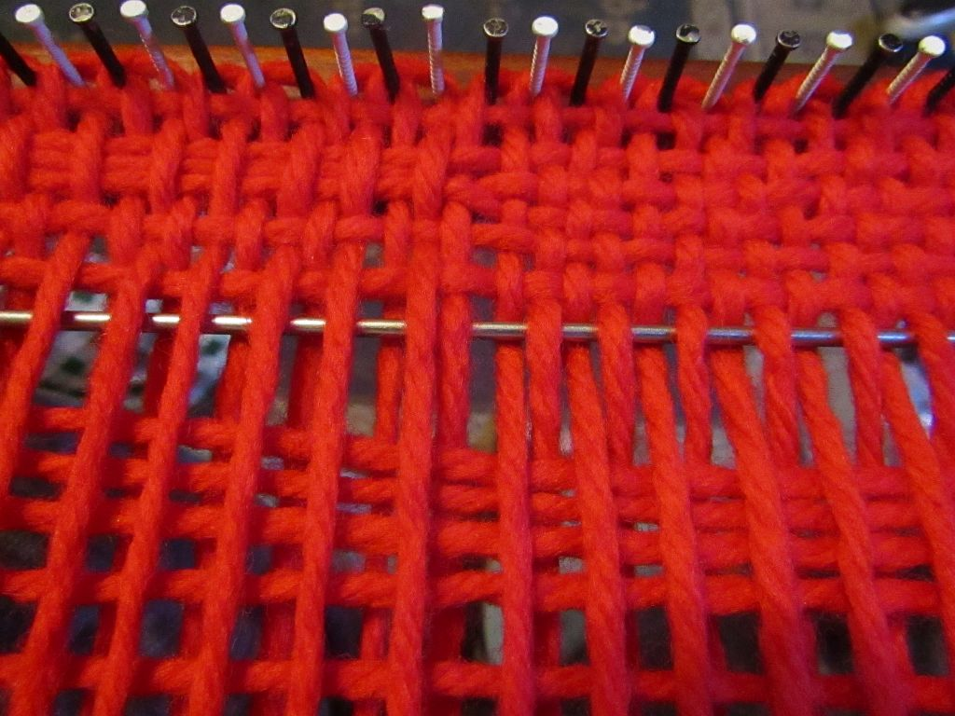
Weave back plain. Repeat these two rows to finish the square, weaving the last row plain.
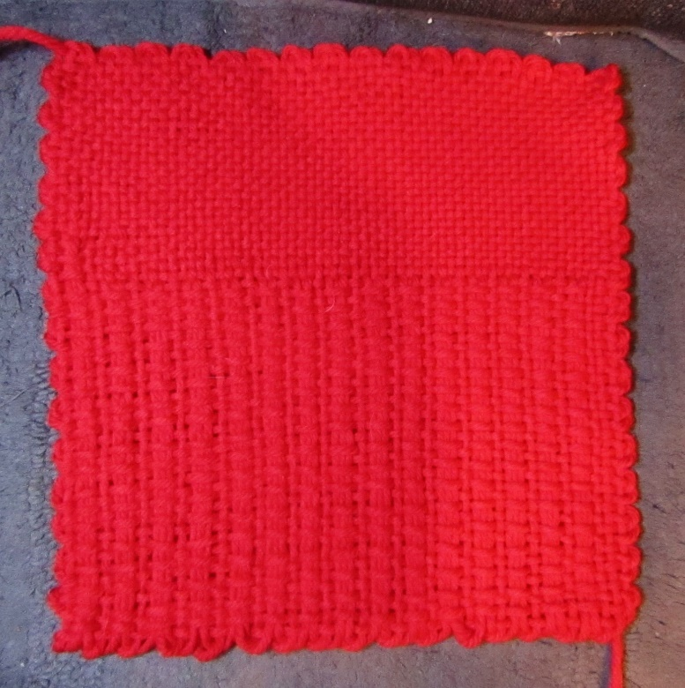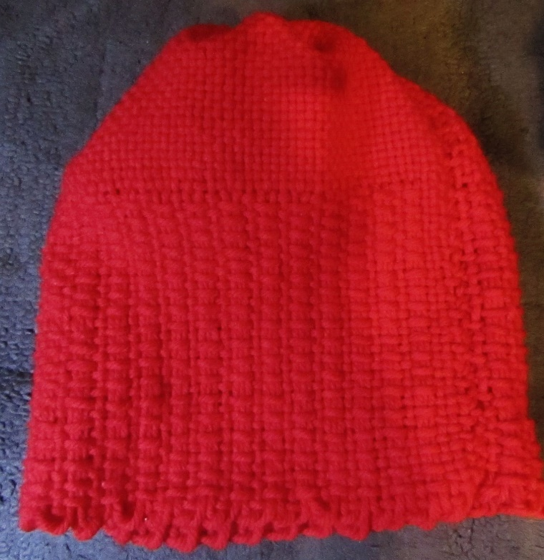
Sew squares into a tube with the faux ribbing (the slide stitch) on the brim edge and the plain weave forming the top of the hat. Fold up the brim to shape the hat.
Adding a tassel is easy and you can make it however you like. 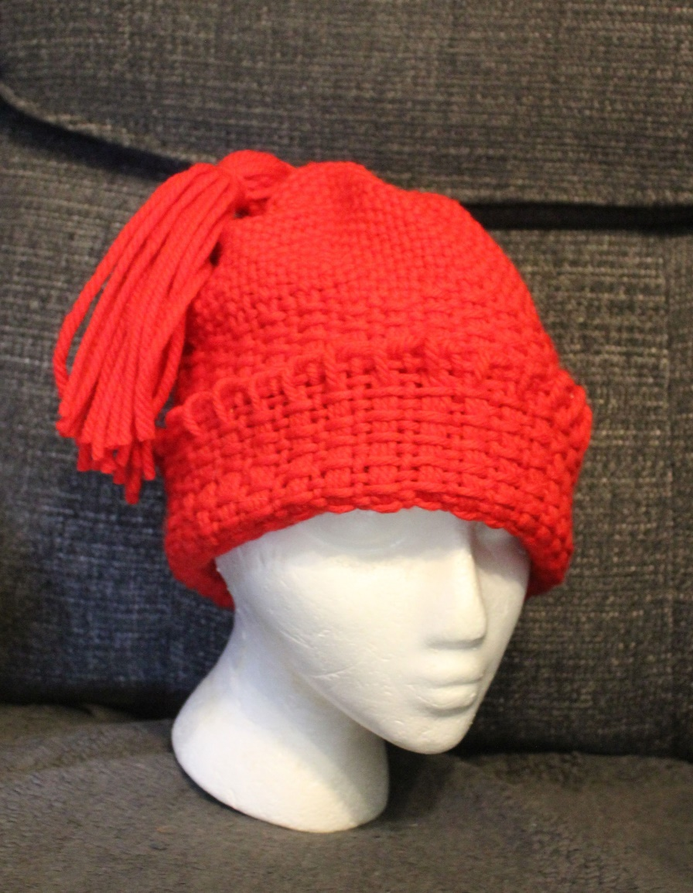
My pattern is offered free as it was inspired by the knitted version but if you are interested you can help here. (cut and paste the link)
ttps://www.goodgoodgood.co/articles/melt-the-ice-hat-donations-pattern-fundraiser

