
Using the SweetHeart Loom to make the rose you'll need one red heart and one green heart. Weave in the short end.
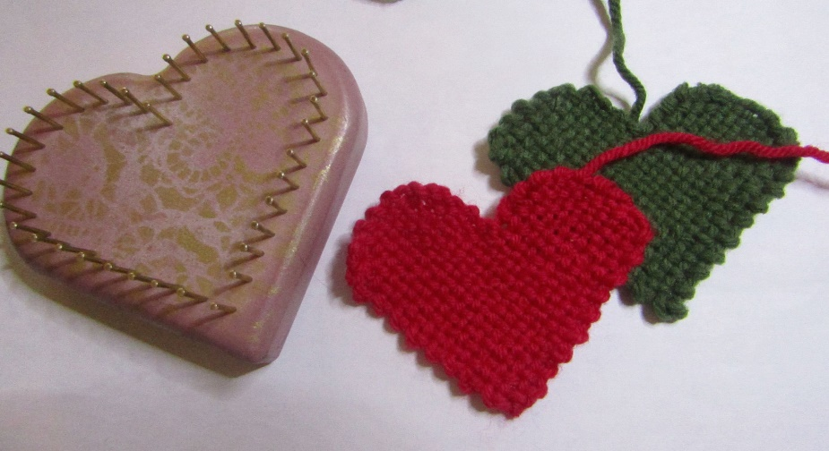
Starting at one side of the red heart, roll it up like a sleeping bag or yoga mat from the point the other side. It will make a sort of an ice cream cone shape.
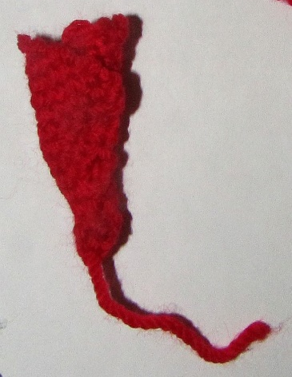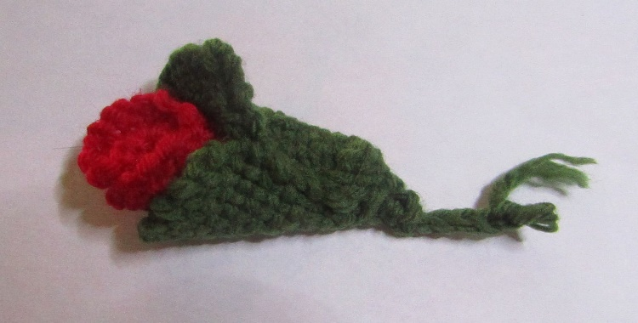
Stitch that roll in place around the bottom and maybe a half inch up the sides to keep it rolled. You'll want the top edge to be a little loose, petal like. Use the green heart the same way, to be the leaf around the bottom of the bud.
Stitch tightly in place using the same green yarn. Using a crochet hook make a short stem with the double chain stitch. *

If you are using the 4" square loom…
To make the rose you'll need one red 4" squares and one green 2" square. Weave in all ends.
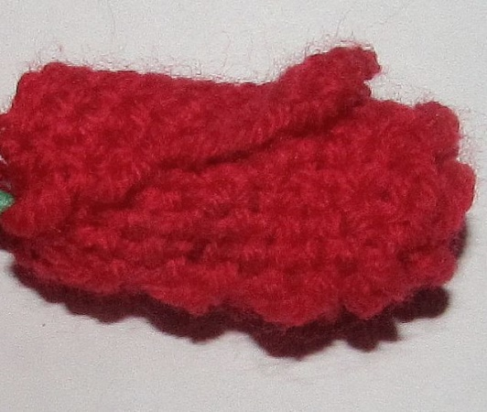
The red square is folded nearly in half and rolled up like a sleeping bag or yoga mat. Stitch that roll in place around the bottom and maybe a half inch up the sides to keep it rolled. You'll want the top edge to be a little loose, petal like.
Stitch a gather stitch around the square in a circle. Fold the 2" green square over the bottom of the bud and pull up the gather stitch to make it snug. Stitch in place with the 4 corners forming the base leaves, using the same green yarn. Using a crochet hook make a short stem with the chain stitch.
