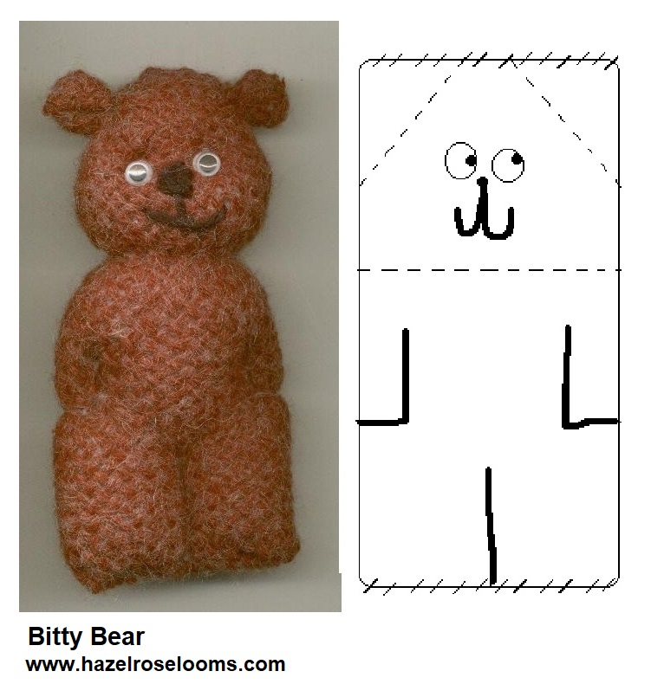
Bitty Bear is made from one densely woven square. You can use your Quilt Weaver Square or your Multi square. The larger your square, the easier it will be to sew but most any size square will work.
If your block looks too thin, if it has little holes, you may want to weave with two strands of yarn held together. You need your fabric to be dense in order to keep the stuffing from showing.
1. Fold your square in half and sew the seam to make a tube. The seam will be the center back. Sew top edge closed. (see the picture).
2. Run a gather stitch at corners for the ears and tie tightly. You don't need to stuff the ears.
3. Run a gather stitch around his neck but stuff his head before tightening it. Pull up just enough to make it looks like a thick bear neck, he doesn't need much.
4. Finish stuffing his body and sew bottom seam.
Stitch through all layers, front to back to make his legs, knot off.
5. For his arms, take a couple over-hand stitches where his paws go and then a few thru all layers, (like the legs) to define his arms.
6. Give him a nose, a three-loop French knot works, and a grin. If you are making this for a little child use French knots for his eyes, also. Mom can show you how. If it's for your Mom you can sew wiggle eyes on. Pull the eyes a bit tight to give his face some shape.
7. Braid or crochet a few inches of yarn for a tail. You know where that goes!

8. He can be made with any size square. If you have a big loom you might want to weave him with wool yarn and felt him in the washing machine before stuffing. Ask Mom about that.
Have fun with your new friend!

