Sunny Cardigan or Jacket
You'll need the 4"Muti Square
A 2x4" Multi rectangle is optional
Sport or dk yarn recommended
Weaving needle and a yarn needle
Weave ten 4 inch squares and two 2x4 inch rectangles Assemble as chart, turning under the top edges if the fronts to make a vee neckline. Seam up the back.

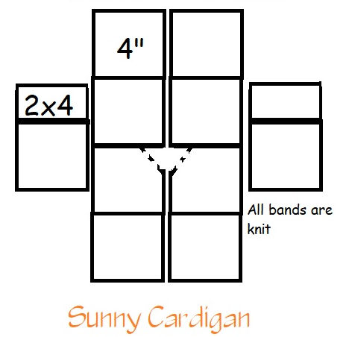
Assemble body of the jacket as the chart shows*. Fold under the two front sections at the shoulder to make the Vee neckline. Sew back seam. Sew the 2x4 to the plain weave 4" squares, putting the 2x4 at the back of the sleeve. Center the sleeve on the shoulder of the jacket. Pin at wrist, arm pit, and hem to be sure they are even. Stitch in place. Sew underarm seam. weave in all ends, turn the jacket.
To make the cardigan, pick up and knit a couple rows of k1, p1 ribbing around the jacket hem, front, and neck line. Bind off. Do the same with the sleeve cuffs. You're on our own for button hole spacing

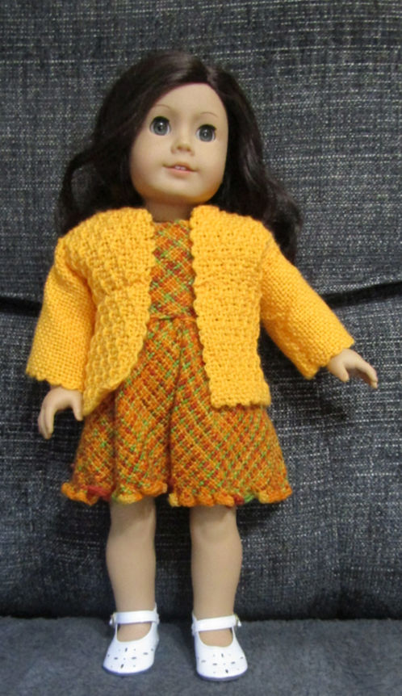
*When assembling the blocks put the double PW rows at shoulder and hem.

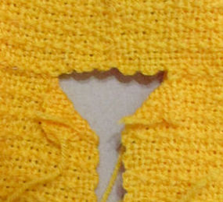
I tried the stitch I think is called the mattress stitch. Through the 2nd loop to the 1st loop in back, then though the next 1stitch to the 2nd stich in front and repeat. You need to have the picots alternating; tho It can be done with them matching. Your seam won't be quite as sung. But, as always, you can use whatever stitch works best for you.
Smocking Stitch for sweater body.
You always weaver OVER the outside loop. It is not mention in instruction!
Warp as usual.
1. PW
2.U1, O3, repeat across, ending U1, O1, O1.
3. PW
Repeat this 2 rows until the last two, which are PW.
The back side of the square is the Smocking stitch, but you can choose your favorite.
