
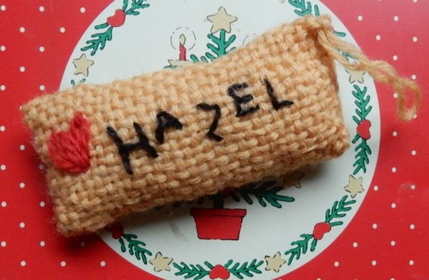
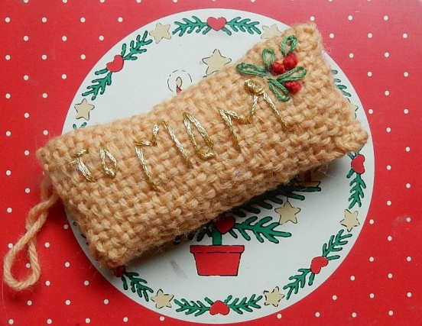
Attached to your gift then added to drawer or closet so smell good all year!

This one is just one square, You can use the four inch but the 6" give you a bit more room for names. If you are using the Quilt Weaver then it would be the 7".
Fold in half, sew the ends flattened, stuffing lightly first. Add scent of your choice. The gold thread I used doesn't how well in a photo but side one says "To Mom" and I embroidered some leaves & berries. Side two has my name in a plain color that shows on the brown better and has a heart.

