
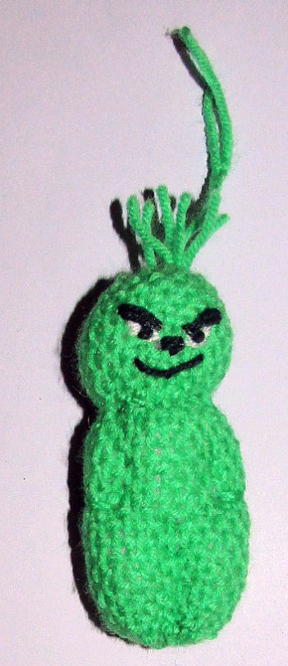
You'll need one square, any size you like, easier if it's at least 4", which is what I used for mine.
Make a tube as usual and gather ends, stuffing moderately firm. Tie his neck rightly. I tried to shape his face a bit but mostly that didn’t work. Make a few larks head knots to give him is top-knot and a hanging loop.
Follow the chart to stitch his arms and legs. You use the matching yarn and stitch all the way though him. There's a couple wraps around to make his hands-in-his-pockets look.
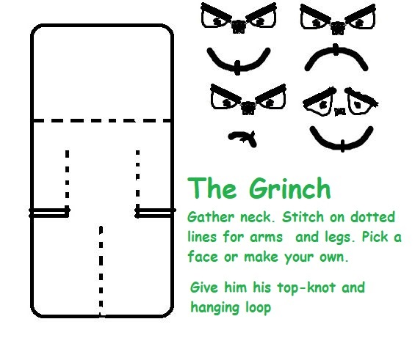
Then give the guy a face. He doesn't always look this snarky so you can give yours whatever expression you prefer.

