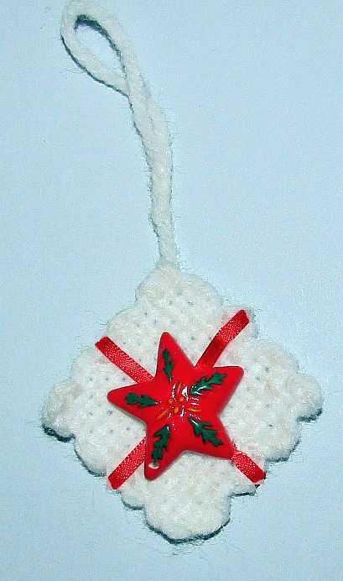
Easy Single Square Pretty!
This one is about as easy as it can get. A single square is all you need for this one. Check your box of practice squares for something that could work for this. And then a little ribbon, tho you could also use a bit of pretty yarn. Weave the square and wrap the ribbon around 'gift style' and stitch or glue in place. Find a pretty and glue in the center. If you don’t have anything suitable just make a nice bow.

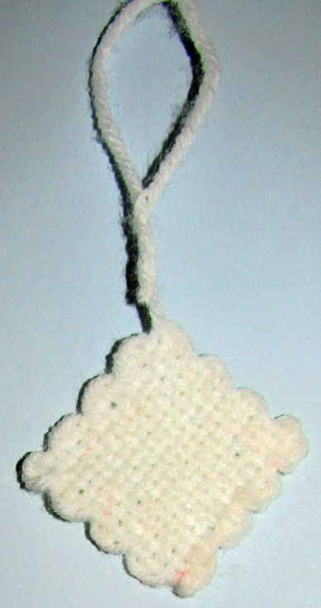
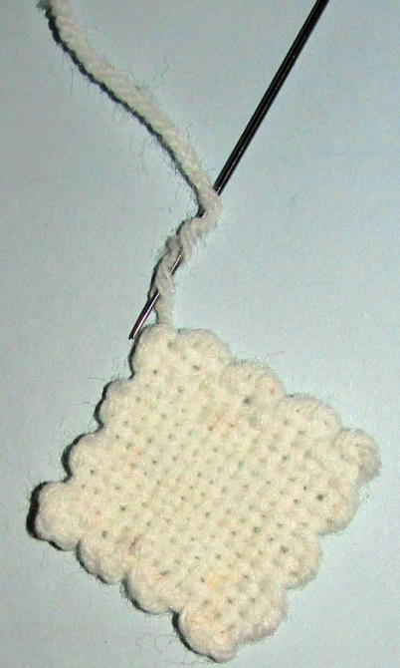
A note on the hanging loop. I used the tail for mine. Thread your Sharp needle with the tail and sew it back into the yarn. Pull it through until you have a loop the size you need and then cut.

It is important to remember that this will pull out if left as is. You need to glue it in. Fabric glue or white "Elmers" glue, maybe tacky glue will work. I do it this way because then I don’t have an extra knot or tail to weave in. As always, you can do it your way!

